Assignment 1-
AMAZON SALES ANALYSIS DASHBOARD USING POWER BI
1. AIM:
To design and implement an interactive Amazon Sales Analysis Dashboard using Microsoft Power BI by extracting, cleaning, transforming, modeling, and analyzing transactional sales data to generate meaningful business insights through KPIs, interactive visualizations, and multiple analytical dashboard pages.

2. OBJECTIVES:
- To understand the complete Business Intelligence workflow using Power BI.
- To import and inspect Amazon sales data using Power Query.
- To identify and handle duplicate and missing records.
- To standardize data types and prepare data for analysis.
- To create calculated columns required for sales analysis.
- To create a dedicated Calendar table for time-based analysis.
- To establish relationships between the Calendar and Amazon sales data.
- To create DAX measures for important business KPIs.
- To analyze revenue, orders, customers, products, and categories.
- To perform time-based sales analysis.
- To create interactive filters and dashboard navigation.
- To develop multiple analytical pages using Power BI.
- To use advanced Power BI analytical features for deeper business insights.
- To present the final analysis through a professional interactive dashboard.

3. TOOLS / SOFTWARE REQUIRED:
- Microsoft Power BI Desktop
- Amazon Sales Dataset
- Power Query Editor – built into Power BI Desktop
- DAX (Data Analysis Expressions)
- Microsoft Excel – if the source dataset is provided in Excel format

4. DATASET USED:
Amazon Sales Dataset
The dataset contains transactional sales information used to analyze sales performance.
Important fields used in the project include:
- OrderDate
- OrderID
- OrderStatus
- UnitPrice
- Quantity
- CustomerID
- Revenue
- Category
A separate Calendar table was also created to support time-based analysis.

5. THEORY:
· Business Intelligence
Business Intelligence (BI) is the process of collecting, transforming, analyzing, and presenting data to support better understanding and decision-making.
Microsoft Power BI provides tools for performing these activities through Power Query, data modeling, DAX, and interactive visualizations.
· Power Query
Power Query is the data preparation and transformation component of Power BI. It allows users to clean and transform raw data before it is loaded into the analytical model.
Typical operations include:
- Removing duplicates
- Handling null values
- Changing data types
- Creating calculated columns
- Filtering records
- Renaming fields
- Preparing data for analysis
· Data Modeling
Data modeling organizes the tables and relationships required for analytical reporting.
In this project, the main transactional table is the Amazon table, while a dedicated Calendar table is used to provide date-related attributes.
· DAX
Data Analysis Expressions (DAX) is the formula language used in Power BI to create analytical measures and calculations.
Examples include:
- Total Revenue
- Total Orders
- AOV
- Unique Customers
- Total Quantity
- Revenue per Customer
· KPI
A Key Performance Indicator (KPI) is a metric used to quickly understand an important aspect of business performance.
The dashboard uses KPIs such as:
- Total Revenue
- Total Orders
- Average Order Value
- Unique Customers
- Total Quantity
· Interactive Dashboard
An interactive dashboard allows users to filter and explore data rather than only viewing static charts.
In this project, interactive features include:
- Date slicers
- Category slicers
- Cross-filtering
- Page navigation
- Interactive analytical visuals
- Product and category exploration

6. PROCEDURE:
Part A: Open Power BI and Load the Dataset
Step 1: Open Microsoft Power BI Desktop
Launch Microsoft Power BI Desktop.
Power BI provides the environment required for data preparation, modeling, DAX calculations, and dashboard creation.

Step 2: Open Power Query
Open the data transformation environment using:
Home → Transform Data
Power Query Editor is used to inspect and prepare the Amazon sales dataset before analysis.
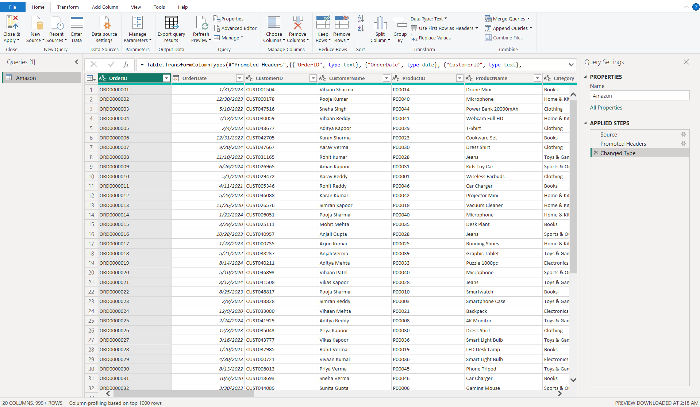
SCREENSHOT 01 — 01_power_query_open

Part B: Data Quality and Cleaning
Step 3: Inspect Data Quality
Examine the Amazon dataset for:
- Missing values
- Invalid values
- Duplicate records
- Incorrect data types
- Inconsistent fields
The purpose is to identify problems before creating calculations and visualizations.
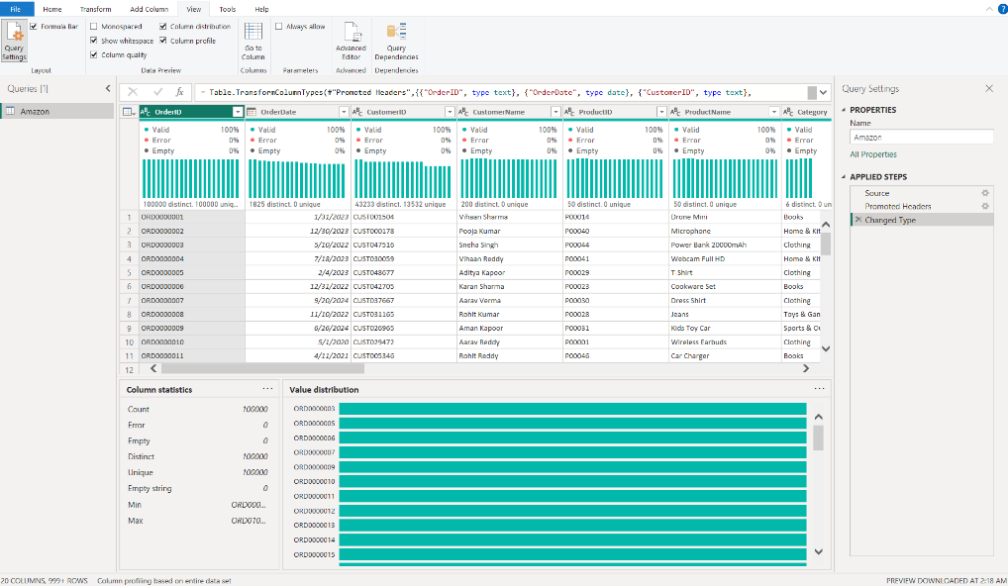
SCREENSHOT 02 — 02_data_quality

Step 4: Remove Duplicate Records
Identify duplicate records in the dataset.
Use Power Query:
Home → Remove Rows → Remove Duplicates
Verify that unnecessary duplicate records have been removed.
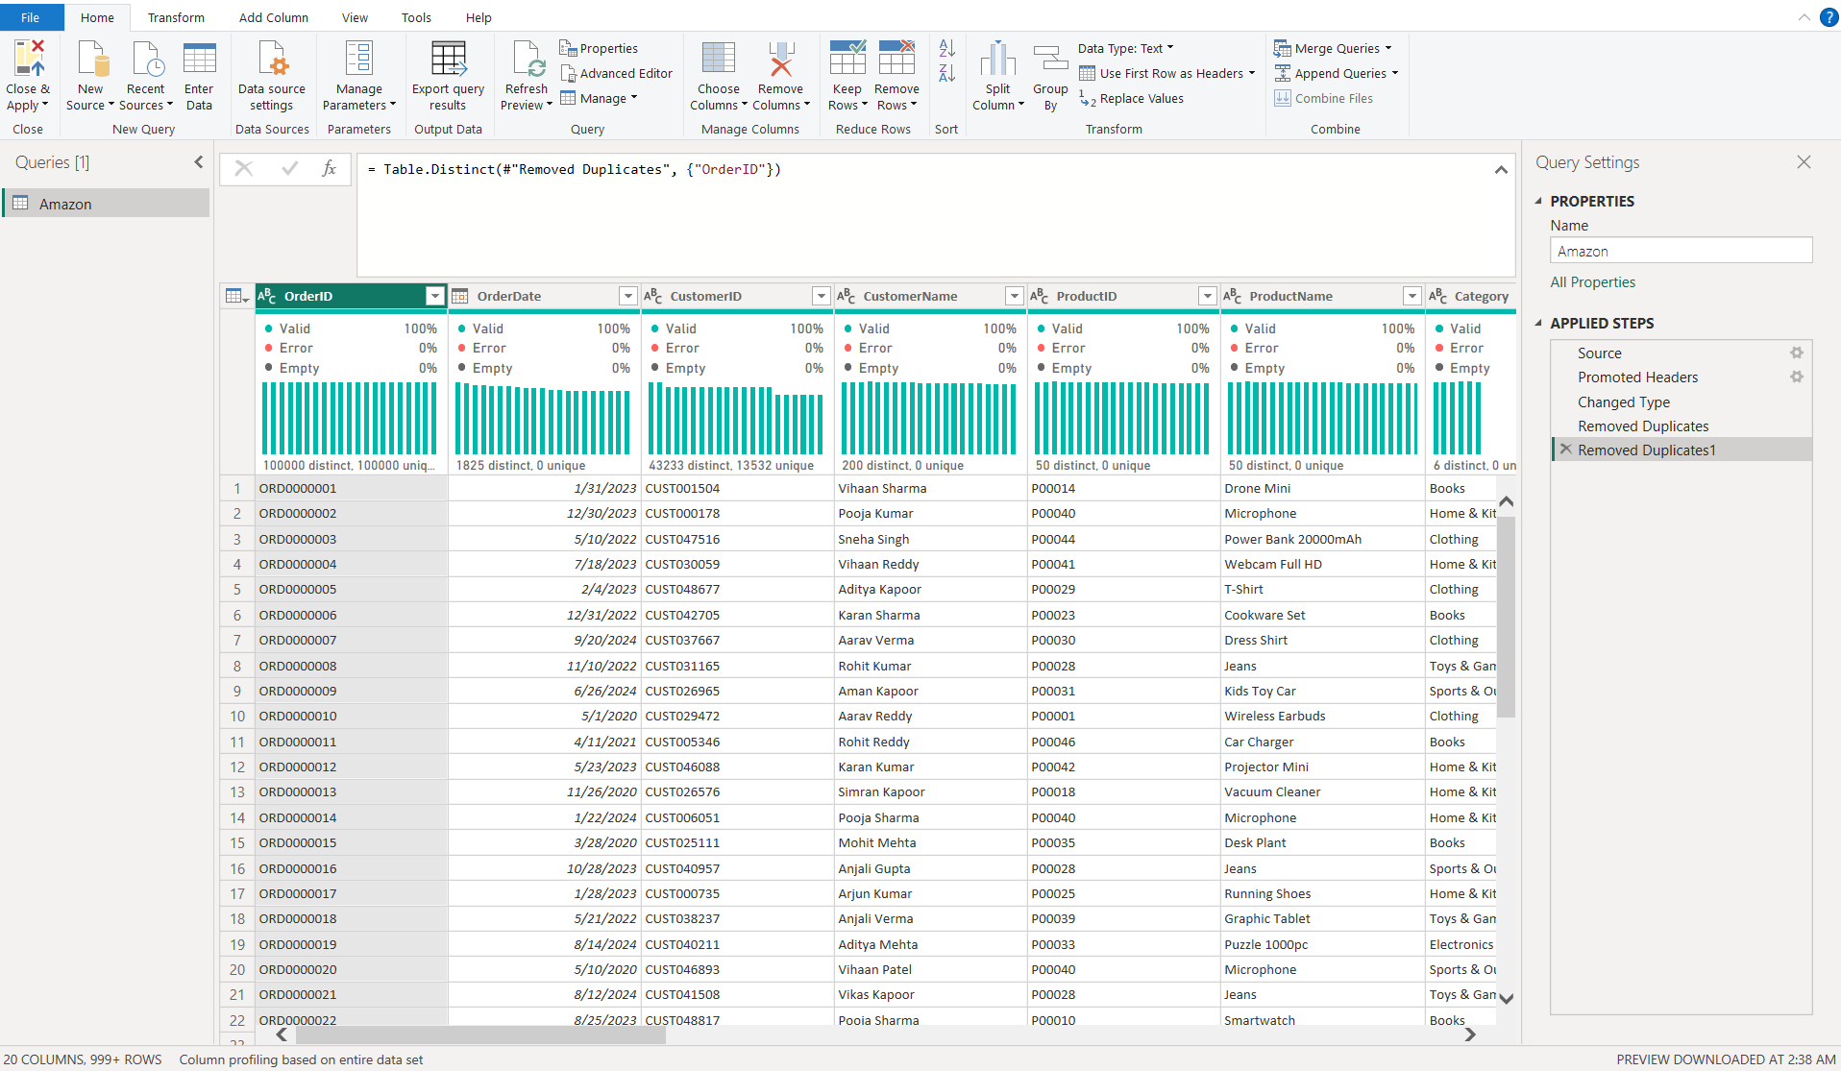
SCREENSHOT 03 — 03_duplicates_removed

Step 5: Handle Null / Blank Values
Inspect columns for null or blank values.
Where appropriate, handle the missing values using Power Query.
The treatment should depend on the nature of the field and should not introduce artificial values into the dataset.
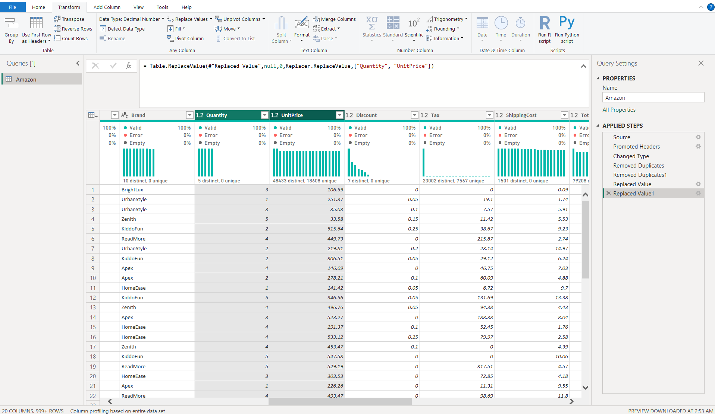
SCREENSHOT 04 — 04_null_handling

Step 6: Correct Data Types
Set appropriate data types for the important fields.
For example:
Field | Data Type
OrderDate | Date
OrderID | Text / Identifier
CustomerID | Text / Identifier
Quantity | Whole Number
UnitPrice | Decimal / Currency
Revenue | Decimal / Currency
OrderStatus | Text
Category | Text
Correct data types are required for reliable calculations and visualizations.
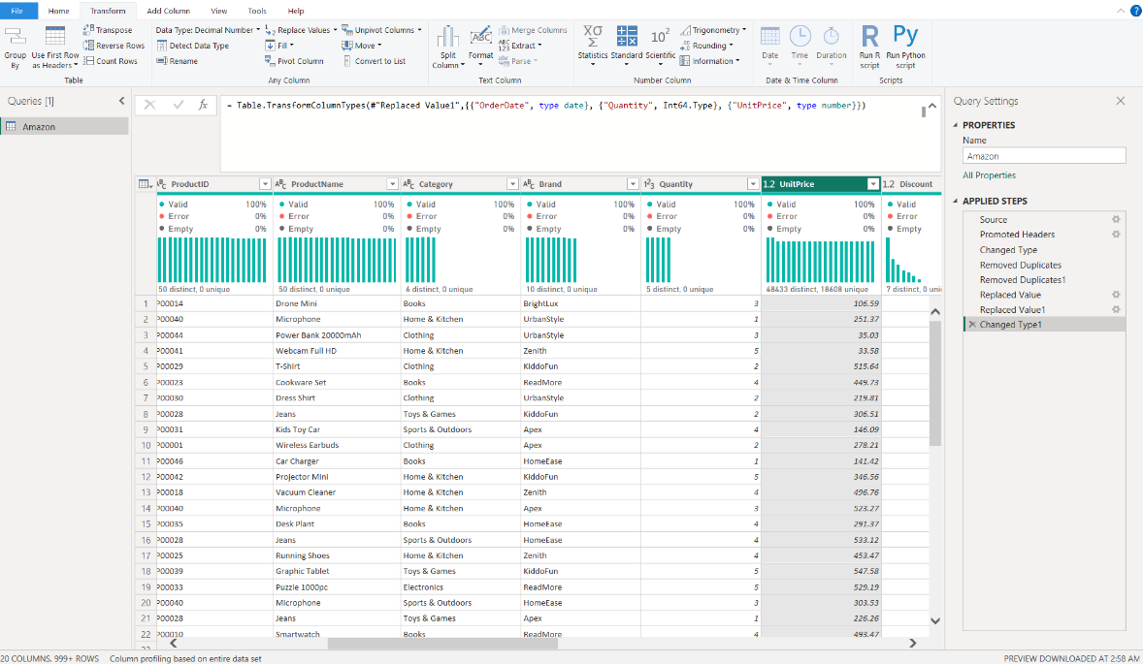
SCREENSHOT 05 — 05_data_types

Part C: Create Required Calculated Columns
Step 7: Create Order Month
Create a month column from OrderDate.
Power Query formula:
Date.MonthName([OrderDate])
This column can be used for monthly analysis.

Step 8: Create Order Year
Create a year column:
Date.Year([OrderDate])
This allows sales to be analyzed by year.

Step 9: Create Month Year
Create a combined month-year field:
Date.MonthName([OrderDate]) & " " &
Number.ToText(Date.Year([OrderDate]))
This field can be used for monthly trend visualizations.

Step 10: Create Quarter
Create the quarter field:
"Q" &
Number.ToText(Date.QuarterOfYear([OrderDate]))
This allows quarterly revenue analysis.
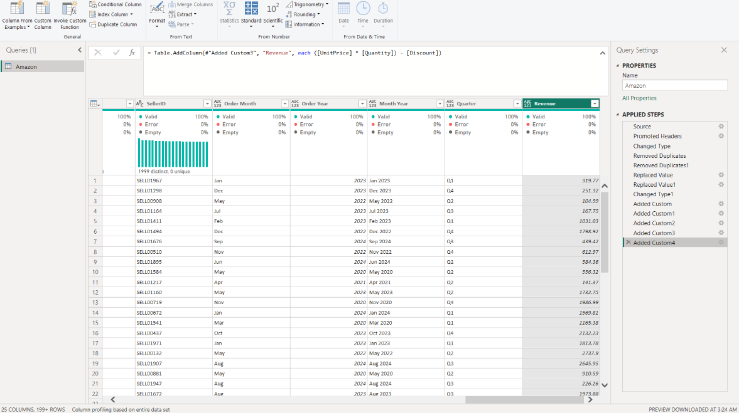
SCREENSHOT 06 — 06_calculated_columns

Part D: Load the Prepared Data
Step 11: Load Data into Power BI
After completing the required transformations:
- Click Close & Apply.
- Allow Power BI to load the transformed dataset.
- Verify that the Amazon table is available in the model.
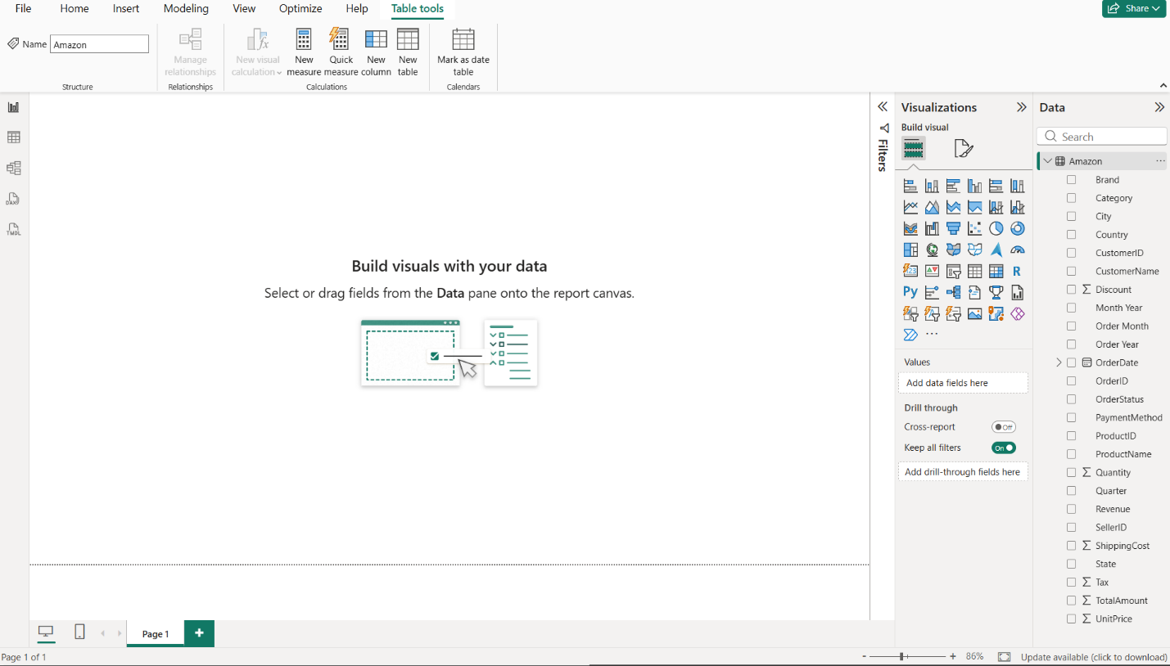
SCREENSHOT 07 — 07_data_loaded

Part E: Create Calendar Table
Step 12: Create Calendar Table
Create a dedicated Calendar table using DAX.
Example:
Calendar =
CALENDAR(
MIN('Amazon'[OrderDate]),
MAX('Amazon'[OrderDate])
)
The Calendar table provides a structured date dimension for time-based analysis.
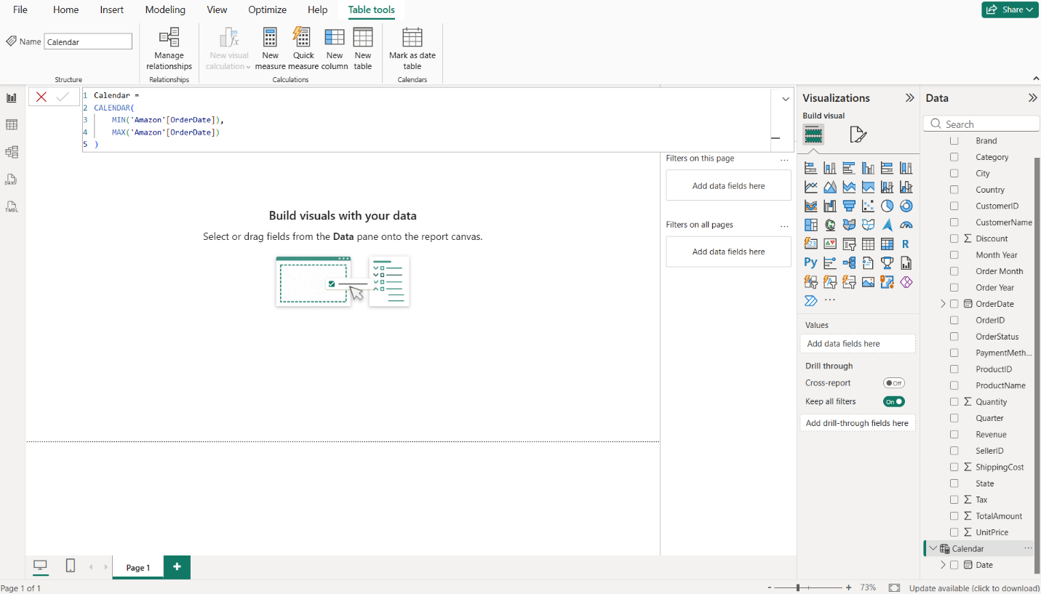 SCREENSHOT 08 — 08_calendar_table

Step 13: Create Calendar Columns
Create the required date attributes.
Examples:
Year
Year = YEAR('Calendar'[Date])
Month Number
Month Number = MONTH('Calendar'[Date])
Month Name
Month Name = FORMAT('Calendar'[Date], "MMMM")
Full Month Year
Full Month Year =
FORMAT('Calendar'[Date], "MMM YYYY")
Quarter
Quarter =
"Q" & FORMAT('Calendar'[Date], "Q")
Weekday Name
Weekday Name =
FORMAT('Calendar'[Date], "dddd")
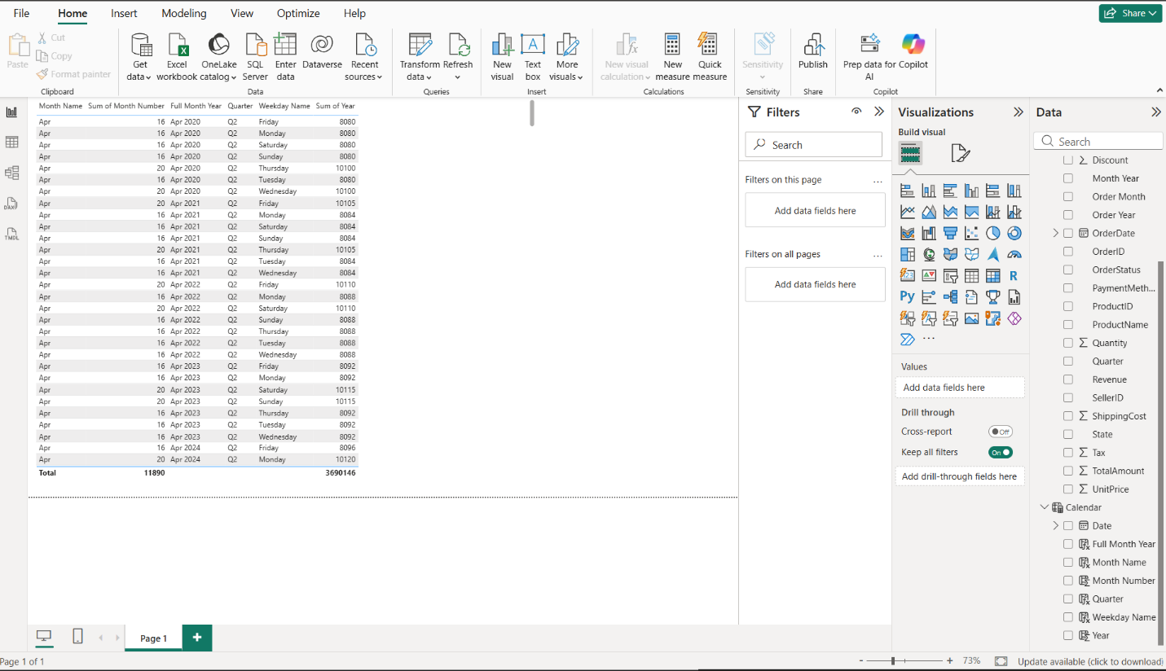
SCREENSHOT 09 — 09_calendar_columns

Part F: Create Table Relationship
Step 14: Create Relationship
Open:
Model View
Create the relationship between:
Calendar[Date]
and
Amazon[OrderDate]
The Calendar table should be used to control time-based filtering of the Amazon sales data.
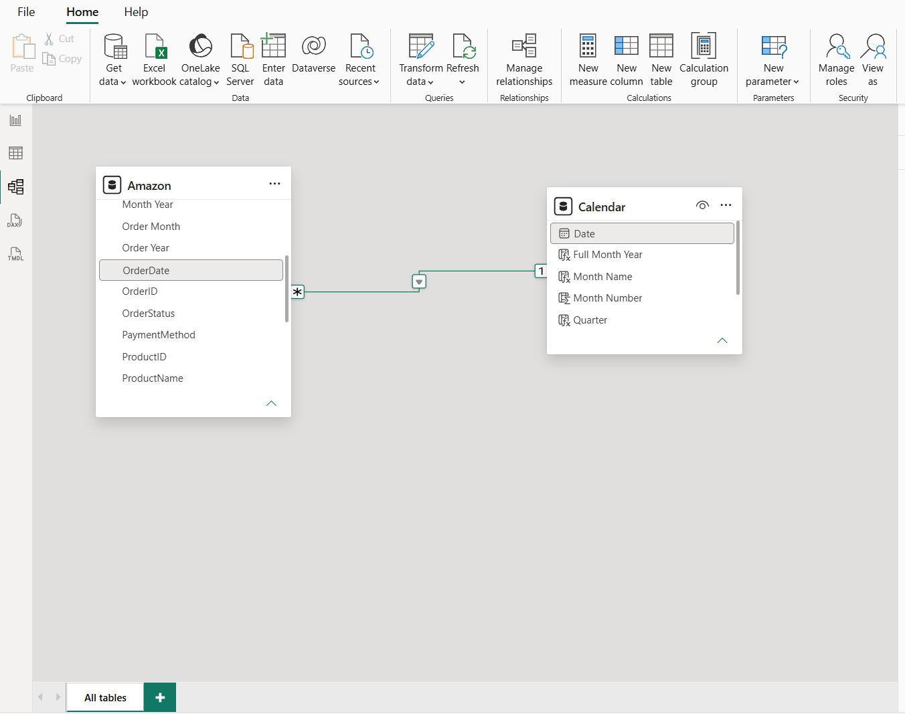
SCREENSHOT 10 — 10_relationship

Step 15: Mark Calendar as Date Table
Select the Calendar table.
Go to:
Table tools → Mark as date table
Select:
Calendar[Date]
This identifies the Calendar table as the official date table for time-based analysis.
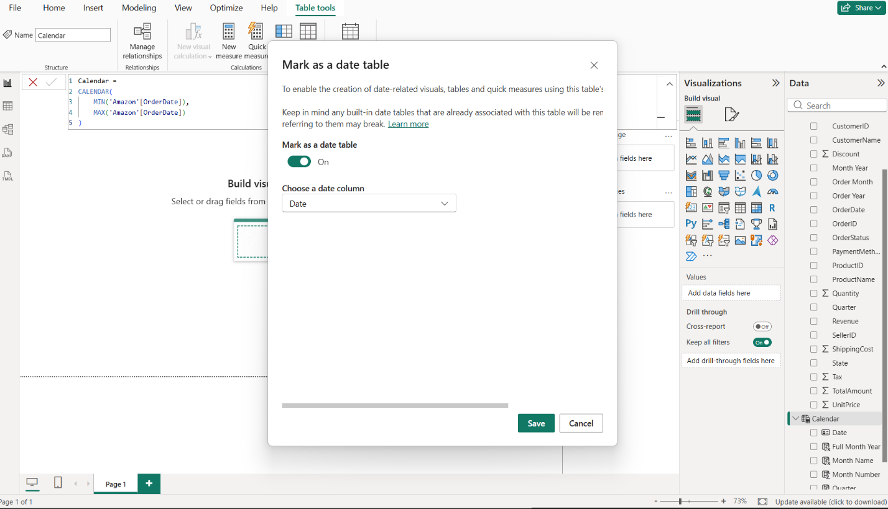 SCREENSHOT 11 — 11_mark_date_table

Part G: Create DAX Measures
Step 16: Create Total Revenue
Create a new measure:
Total Revenue =
SUM('Amazon'[Revenue])
This measure calculates the total revenue generated.

Step 17: Create Total Orders
Total Orders =
DISTINCTCOUNT('Amazon'[OrderID])
This calculates the number of unique orders.

Step 18: Create Average Order Value
AOV =
DIVIDE(
[Total Revenue],
[Total Orders]
)
AOV represents the average revenue generated per order.

Step 19: Create Unique Customers
Unique Customers =
DISTINCTCOUNT('Amazon'[CustomerID])

Step 20: Create Total Quantity
Total Quantity =
SUM('Amazon'[Quantity])

Step 21: Create Average Quantity
Average Quantity =
AVERAGE('Amazon'[Quantity])

Step 22: Create Revenue per Customer
Revenue per Customer =
DIVIDE(
[Total Revenue],
[Unique Customers]
)
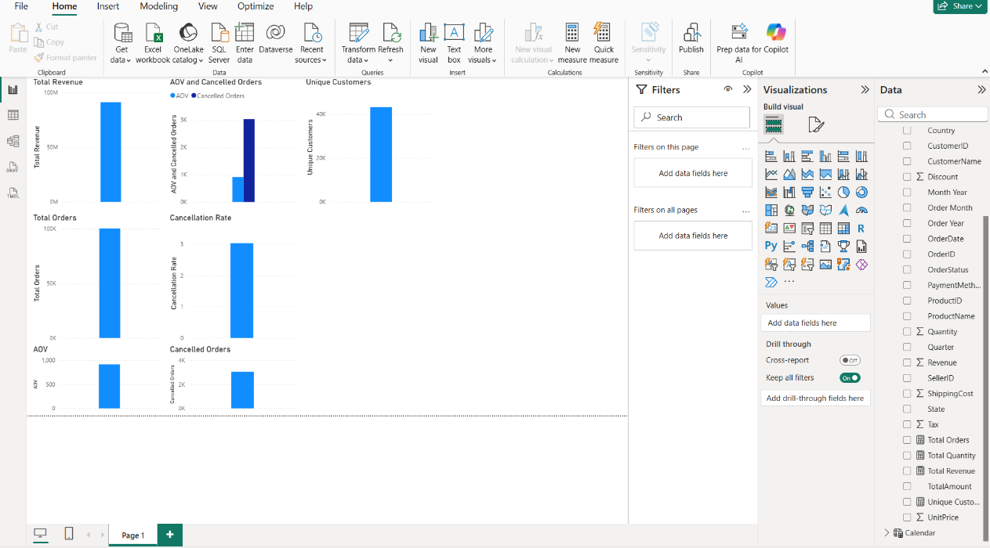
SCREENSHOT 12 — 12_all_measures

Part H: Create Basic KPI Visualizations
Step 23: Create Total Revenue Card
Insert:
Card visual
Add:
Total Revenue
Configure the card to clearly display the overall revenue.
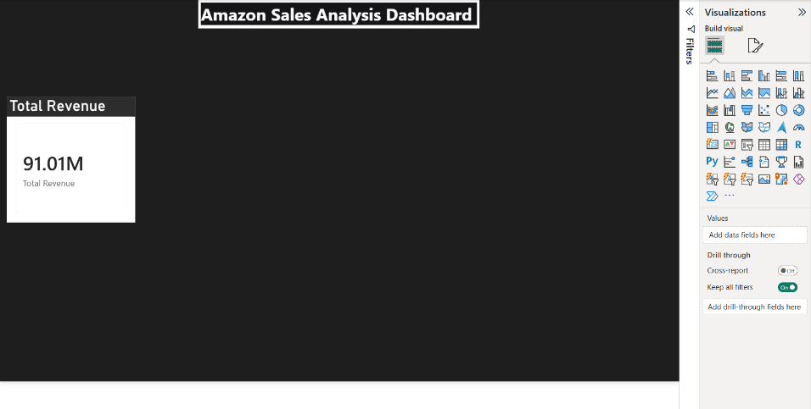
SCREENSHOT 13 — 13_revenue_card.

Step 24: Create KPI Cards
Create additional cards for:
- Total Revenue
- Total Orders
- AOV
- Unique Customers
- Total Quantity
Use a consistent professional design.
Recommended design:
- Background: #1E1E1E
- Main page background: #111111
- Text: #FFFFFF
- Accent: #FF9900
- 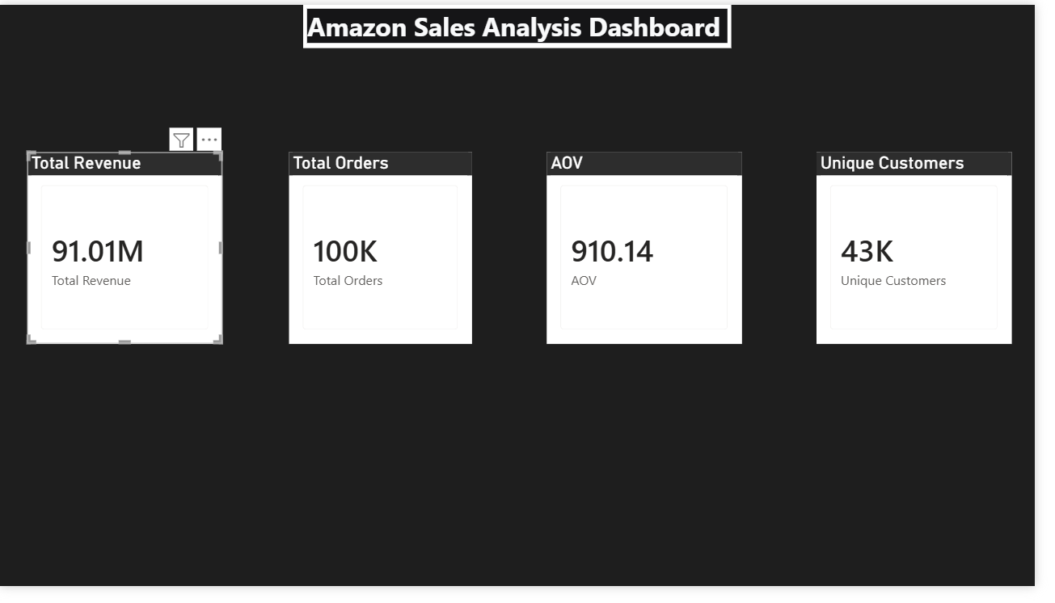
SCREENSHOT 14 — 14_all_cards

Part I: Revenue Trend Visualization
Step 25: Create Revenue Trend
Insert:
Line chart / Area chart
Configure:
X-axis:
Calendar[Full Month Year]
Values:
Total Revenue
Title:
Revenue Trend
The visualization allows revenue performance to be examined over time.
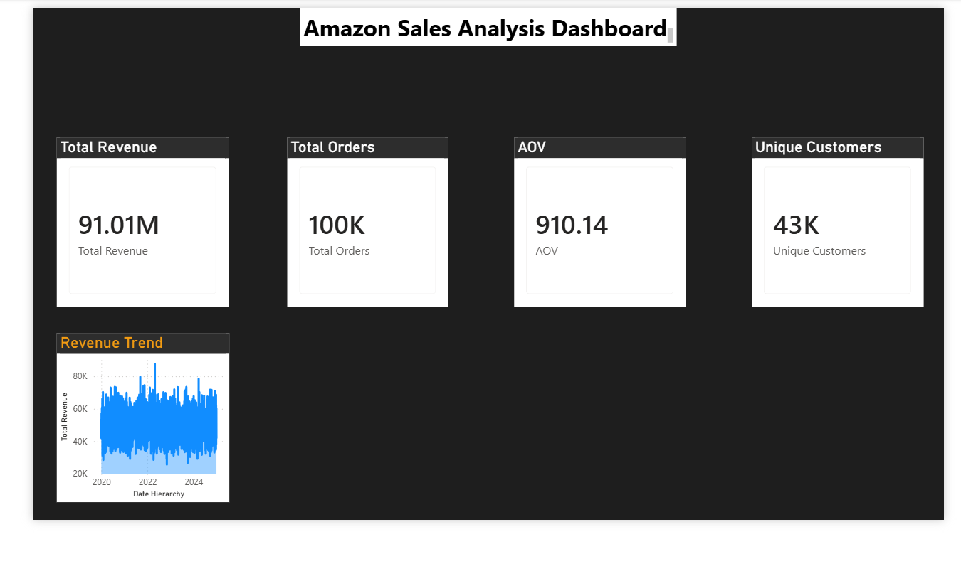
SCREENSHOT 15 — 15_revenue_trend

Part J: Category Analysis
Step 26: Create Revenue by Category
Insert:
Clustered Bar Chart
Configure:
Axis:
Amazon[Category]
Values:
Total Revenue
Title:
Revenue by Category
Sort the chart by Total Revenue in descending order.
Enable data labels where appropriate.
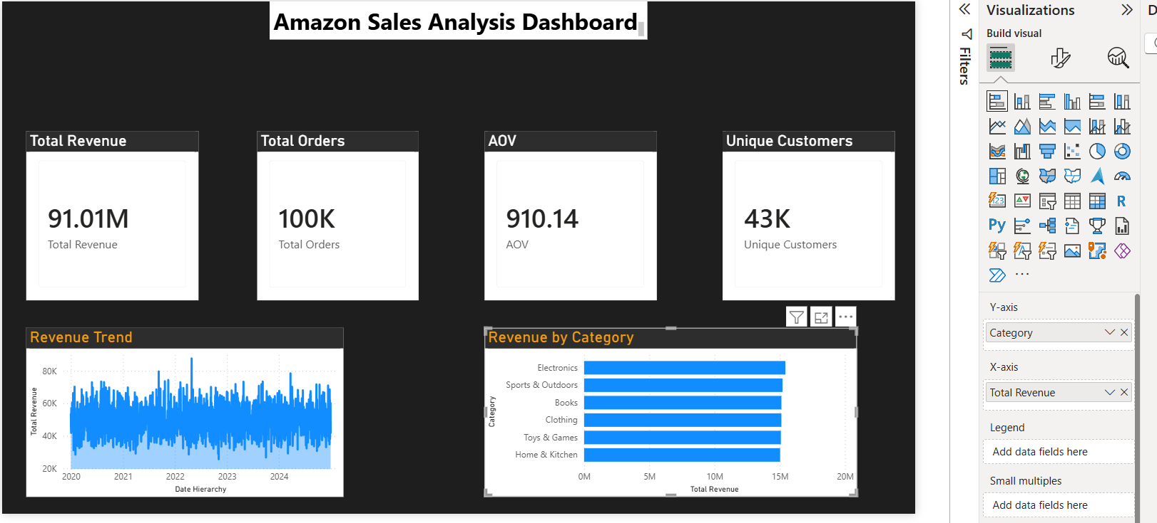
SCREENSHOT 16 — 16_category_chart

PART K: BUILD THE MULTI-PAGE INTERACTIVE DASHBOARD
The basic visuals created above are combined into a professional multi-page Power BI report.
The final report consists of multiple analytical views rather than a single page.

PAGE 1 — EXECUTIVE OVERVIEW
Step 27: Create Executive Overview
Create/rename the first dashboard page:
01 Executive Overview
The page contains:
- Report title
- Navigation
- Date filter
- Category filter
- KPI cards
- Revenue trend
- Revenue by category
- Product performance
- Executive performance summary
Purpose
To provide a high-level summary of the Amazon sales business.
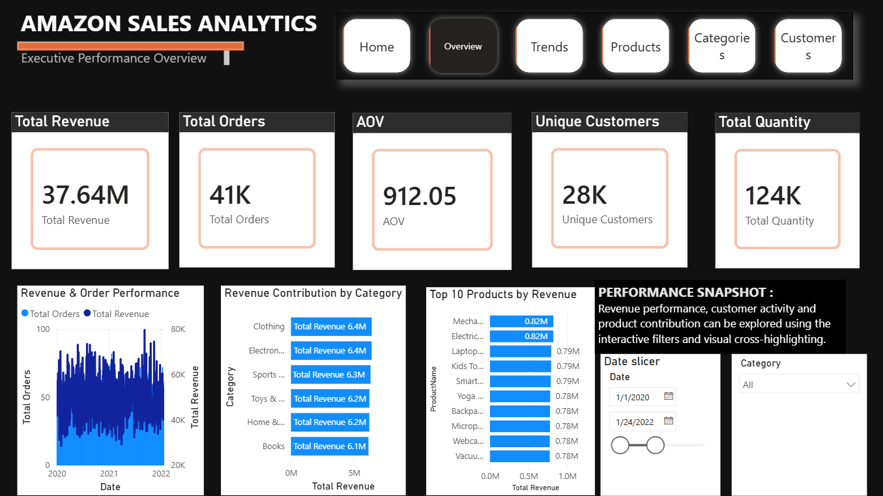
SCREENSHOT 17 — 17_executive_overview.

PAGE 2 — SALES TRENDS
Step 28: Create Sales Trends Page
Create a new page:
02 Sales Trends
Add interactive slicers such as:
- Date
- Category
Create visuals for:
- Monthly revenue
- Monthly orders
- Orders by weekday
- Revenue by quarter
Purpose
To analyze how sales performance changes over time.
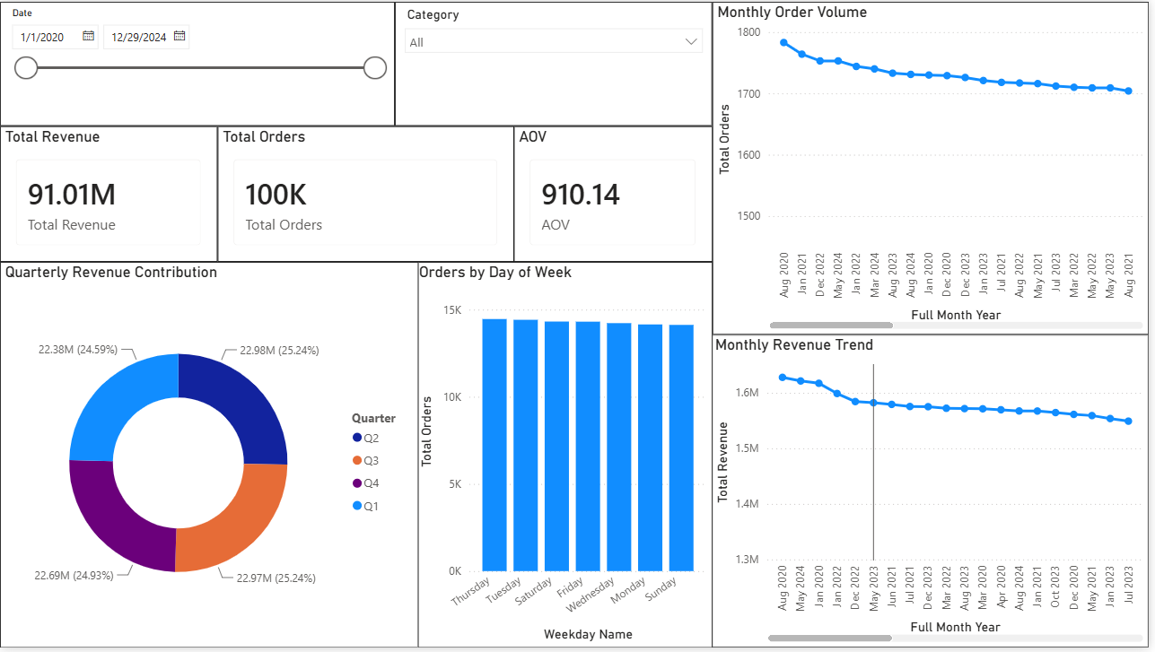
SCREENSHOT 18 — 18_sales_trends

PAGE 3 — PRODUCT PERFORMANCE
Step 29: Create Product Performance Page
Create:
03 Product Performance
Use available product-related fields to analyze:
- Revenue by product
- Orders by product
- Product performance
- Top-performing products
Where applicable, use Top N filtering to identify the leading products.
The reference dashboard similarly uses product-level revenue analysis to compare individual products.
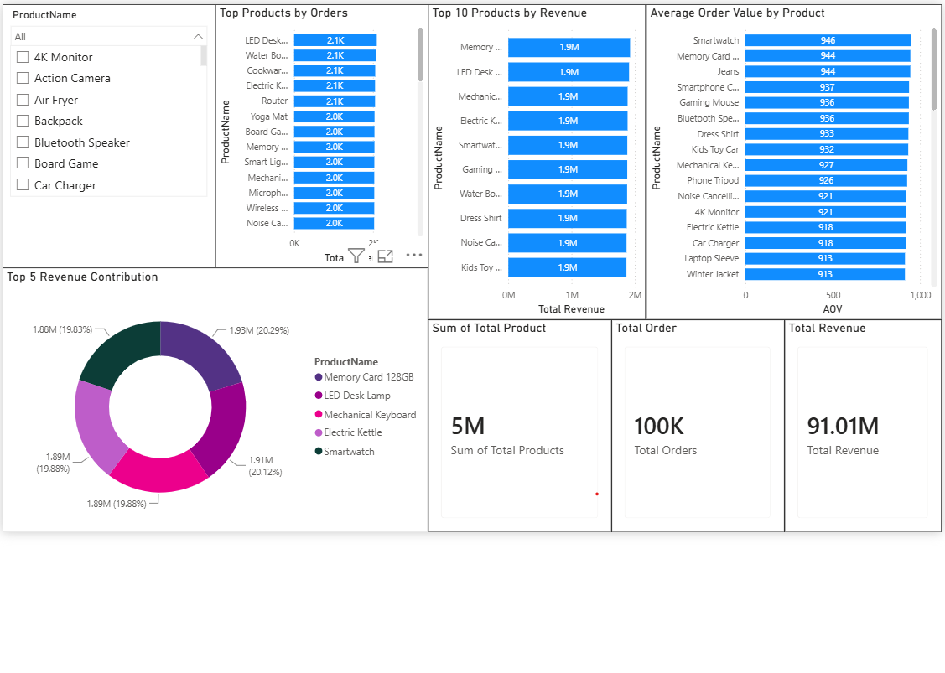
SCREENSHOT 19 — 19_product_performance

PAGE 4 — REVENUE DEEP DIVE
Step 30: Create Revenue Deep Dive
Create:
04 Revenue Deep Dive
This page provides a deeper investigation of revenue.
Use analytical visuals such as:
- Revenue by category
- Revenue by product
- Revenue trend
- KPI cards
- Decomposition Tree, where available
A Decomposition Tree can be used to break Total Revenue down by dimensions such as Category and Product.
This follows the analytical concept demonstrated in the reference report's Revenue Decomposition Tree.
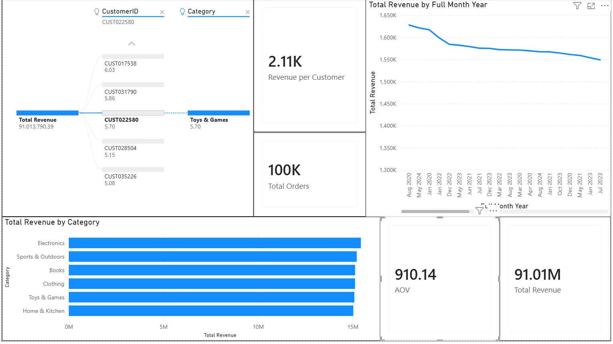
SCREENSHOT 20 — 20-Revenue Deep Dive

PAGE 5 — PERFORMANCE INSIGHTS
Step 31: Create Performance Insights
Create:
05 Performance Insights
This page is designed for deeper analytical investigation.
Where supported by the available data and Power BI version, use:
- Key Influencers
- Revenue anomaly detection
- Trend analysis
- Performance comparisons
The reference report demonstrates Key Influencers and anomaly-oriented revenue analysis as examples of advanced analytical reporting.
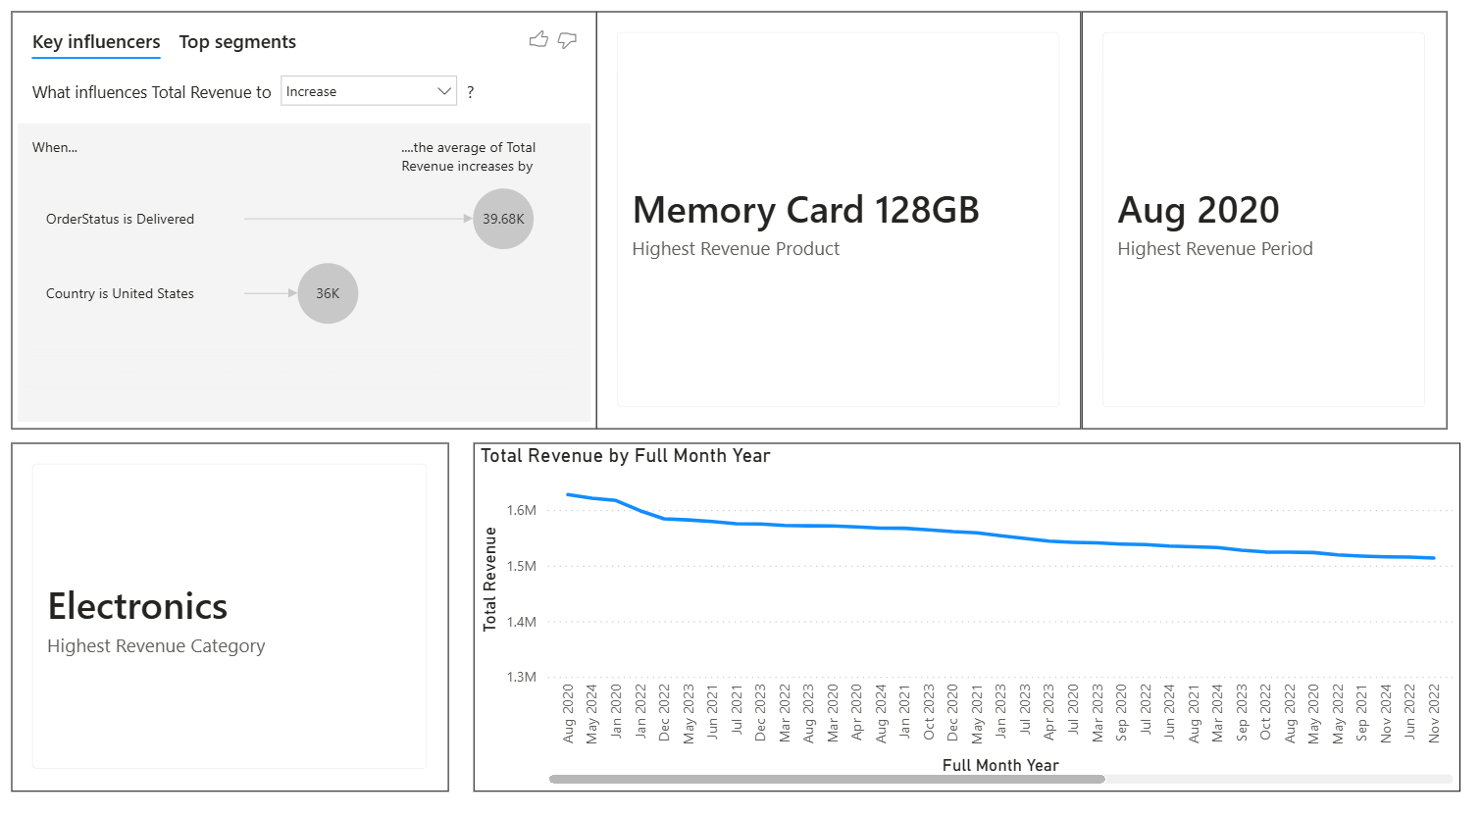
SCREENSHOT 21 — 21-Performance Insights

PAGE 6 — EXECUTIVE INSIGHTS
Step 32: Create Executive Insights
Create:
06 Executive Insights
The purpose of this page is to summarize the major patterns identified from the dashboard.
Include:
- KPI summary
- Revenue performance
- Category performance
- Product performance
- Trend visualization
- Important observations
The page should focus on communicating findings clearly rather than displaying excessive numbers.
The sample report also uses summary-oriented analytical elements to communicate revenue trends and observations.
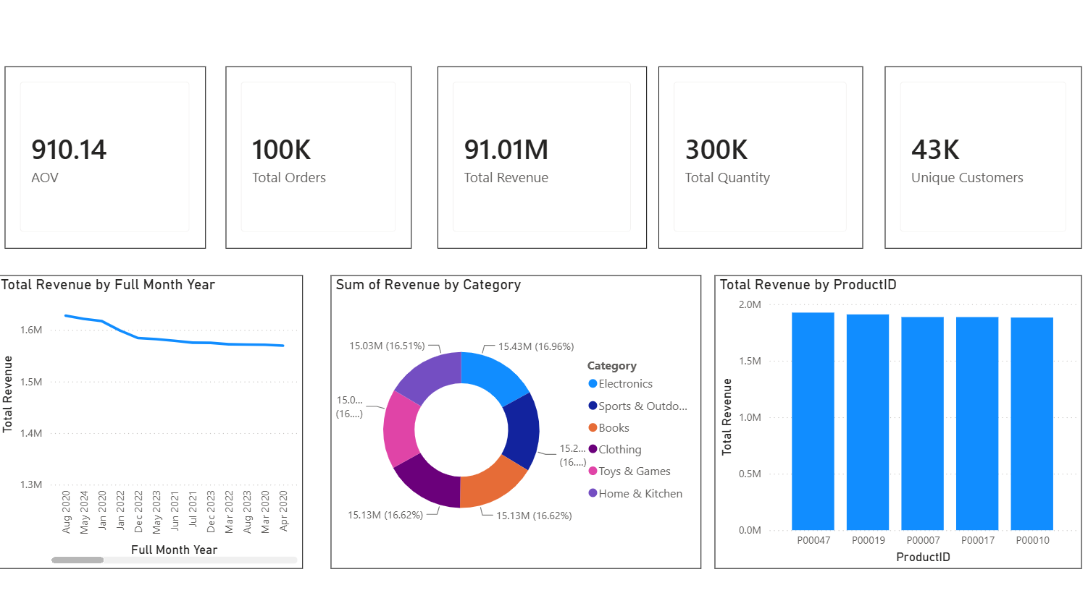
SCREENSHOT 22 — 22-Executive Insights

PAGE 7 — GEOGRAPHIC ANALYSIS
Step 33: Create Geographic Analysis
Create:
07 Geographic Analysis
Use the geographical fields available in the dataset.
Possible fields include:
- Region
- Country
- State
- City
Create appropriate visualizations such as:
- Revenue by region
- Orders by region
- Regional performance
- Geographic contribution
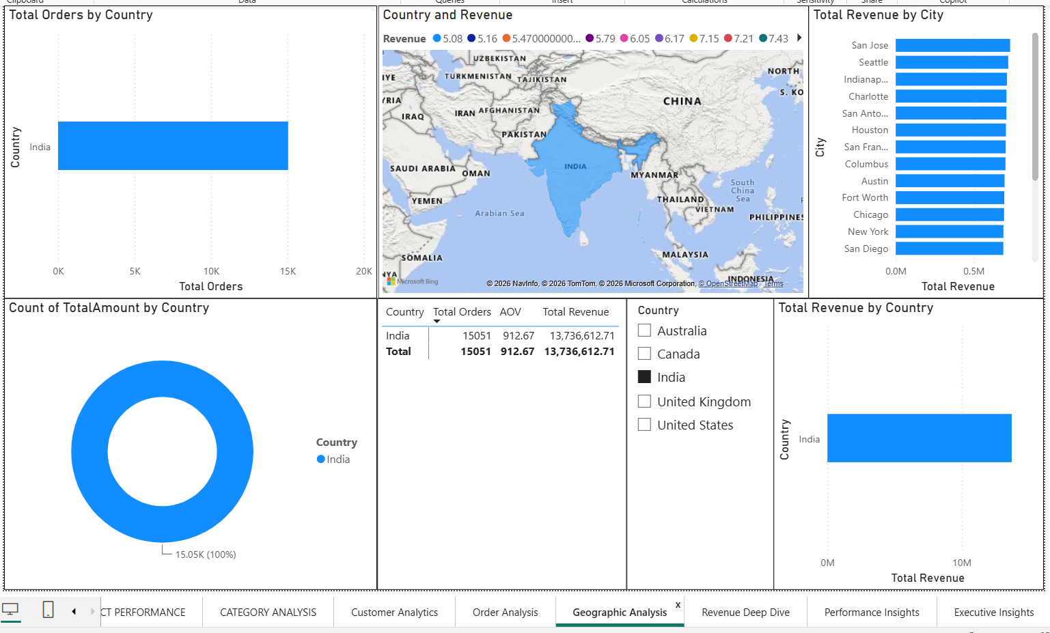
SCREENSHOT 23 — 23-Geographic Analysis

PAGE 8 — PRODUCT PERFORMANCE
Step 34: Create Detailed Product Performance Analysis
Create a detailed product analysis view.
Analyze products according to available measures such as:
- Total Revenue
- Total Orders
- Quantity
- AOV
Use sorting and filtering to identify important product-level patterns.
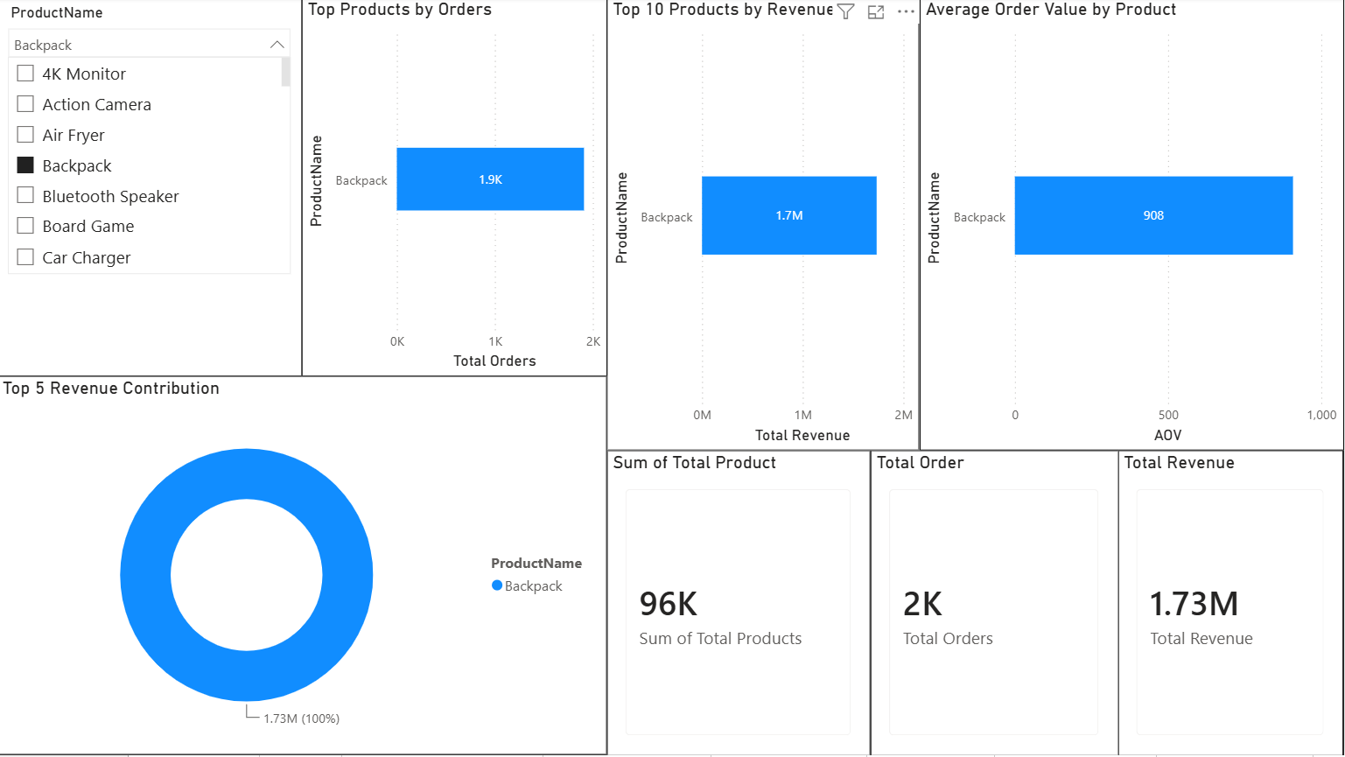
SCREENSHOT 24 — 24-PRODUCT PERFORMANCE

PAGE 9 — CATEGORY ANALYSIS
Step 35: Create Category Analysis
Create:
09 Category Analysis
Analyze:
- Revenue by category
- Orders by category
- AOV by category
- Category contribution
- Category comparison
A matrix can also be used to compare multiple KPIs across categories.
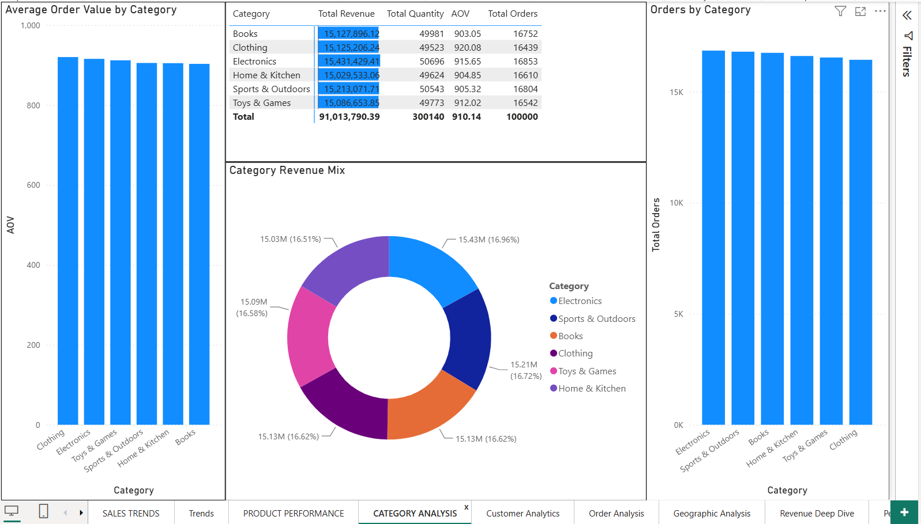
SCREENSHOT 25 — 25-CATEGORY ANALYSIS

PAGE 10 — CUSTOMER ANALYTICS
Step 36: Create Customer Analytics
Create:
10 Customer Analytics
Use:
Amazon[CustomerID]
to analyze customer activity.
Possible analysis includes:
- Unique customers
- Revenue by customer
- Orders by customer
- Revenue per customer
- Customer performance
A Top N filter can be used to examine the highest-revenue customers.
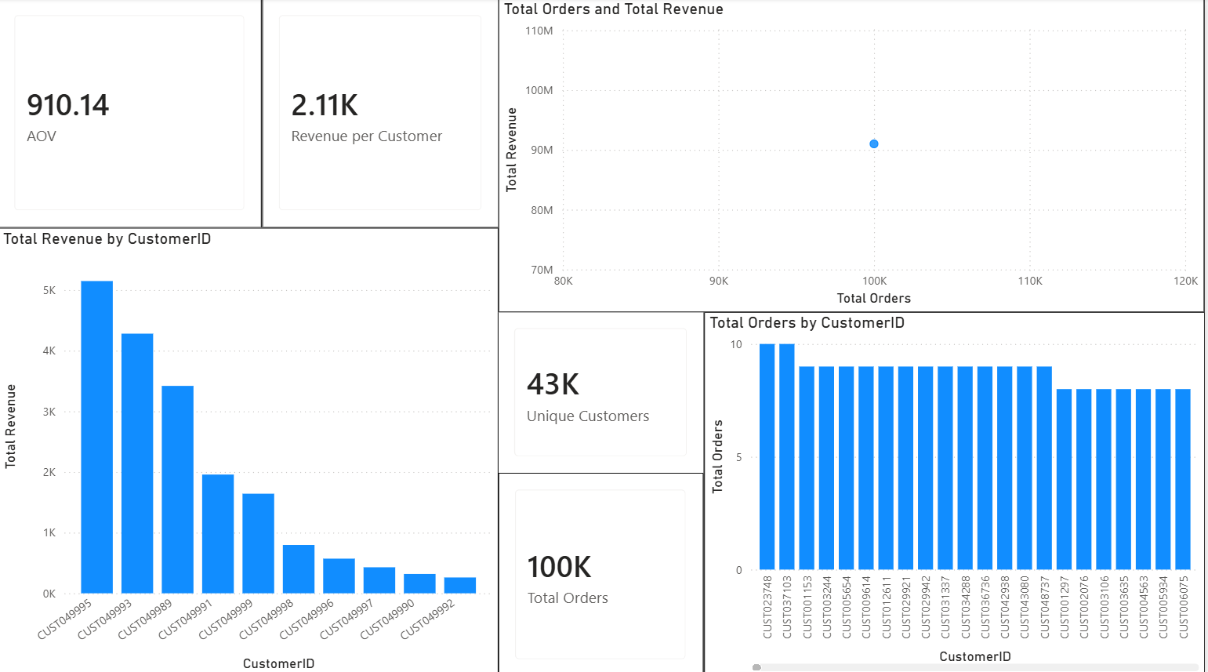
SCREENSHOT 26 — 26-Customer Analytics

PAGE 11 — ORDER ANALYSIS
Step 37: Create Order Analysis
Create:
11 Order Analysis
Use:
Amazon[OrderStatus]
to analyze order performance.
Create visuals such as:
- Orders by status
- Revenue by status
- Order status distribution
- Order status over time
- Category versus order status
- 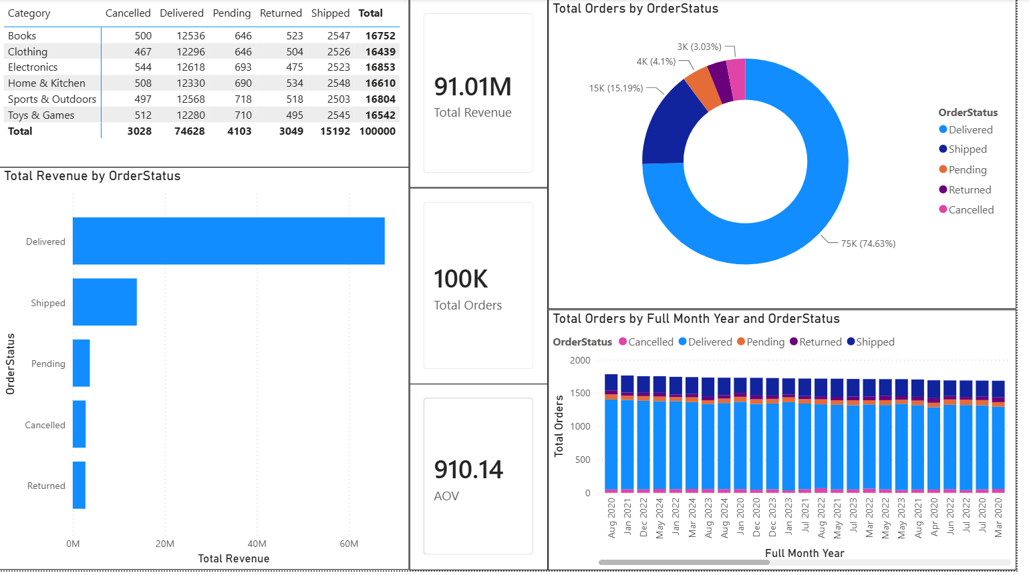
SCREENSHOT 27 — 27-Order Analysis

Part L: Interactive Navigation
Step 38: Create Button/Page Navigator
To make the report easier to navigate:
- Go to Insert.
- Select Buttons.
- Select Navigator.
- Select Page navigator.
- Position the navigator at the top of the dashboard.
- Format the selected and unselected states.
The navigator provides access to the different dashboard pages.
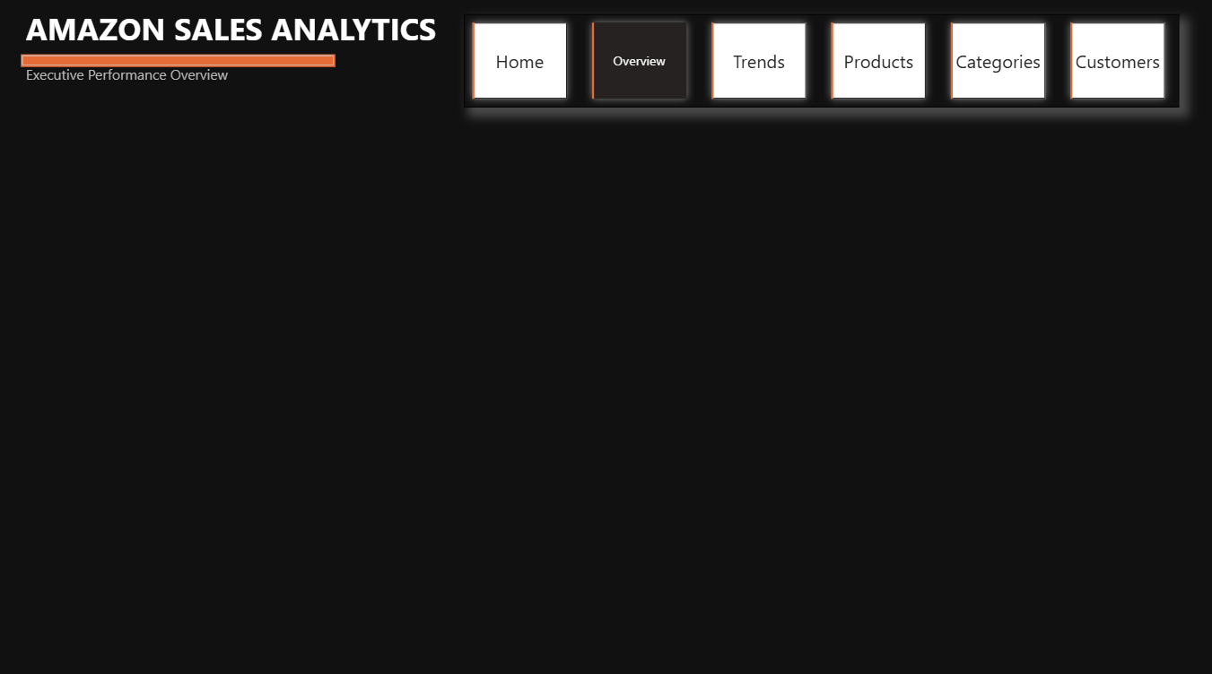
SCREENSHOT — Button Navigator

Part M: Final Dashboard Overview
Step 39: Verify Full Report
Review the complete report and verify:
- All pages are accessible.
- Navigation works correctly.
- Slicers filter the visuals.
- KPI cards respond to filters.
- Charts display correct data.
- No visuals overlap.
- Titles are readable.
- Formatting is consistent.
- Data is displayed using appropriate numerical formats.
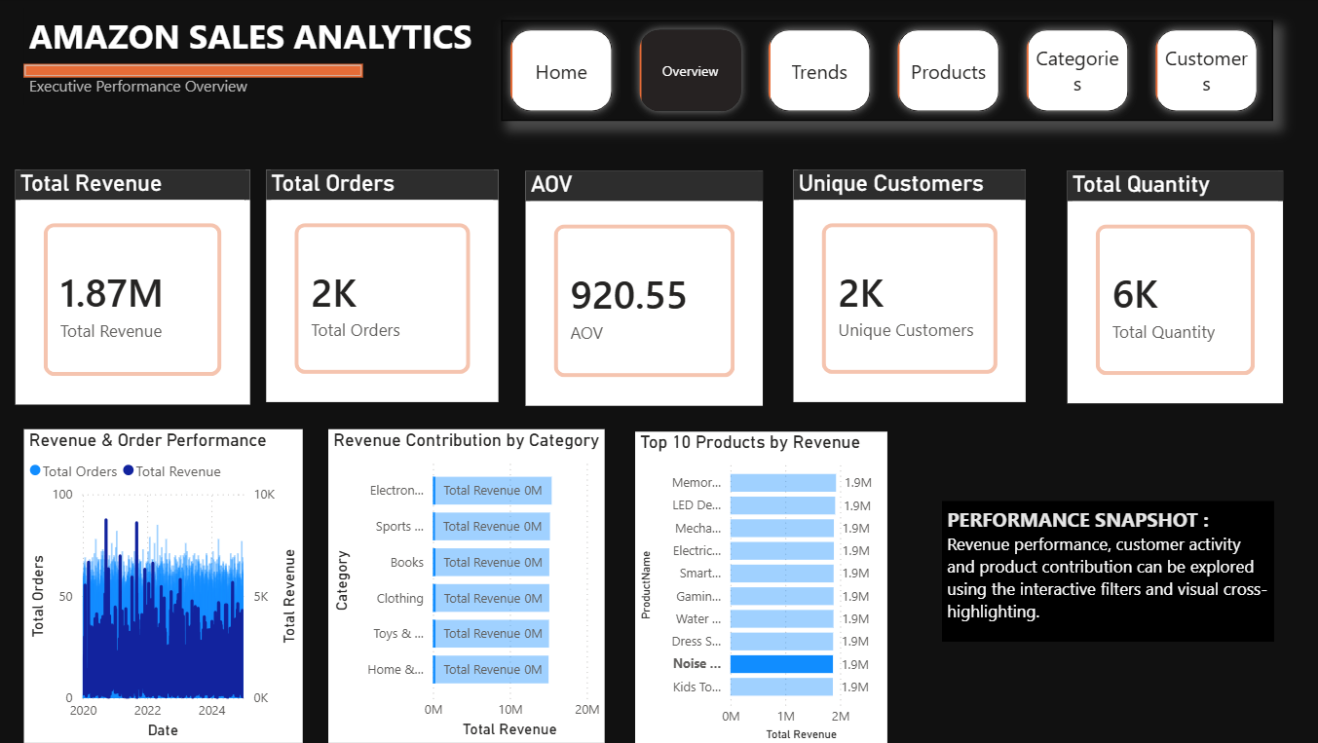
SCREENSHOT — Full Overview Page

Part N: Final Overview
Step 40: Verify Overview Page
Return to the main overview page.
Check that the page provides a clear summary of:
- Total Revenue
- Total Orders
- AOV
- Customers
- Quantity
- Revenue trend
- Category performance
- Product performance
- Navigation
📸 SCREENSHOT — Overview Page.png
Take the final overview screenshot.
Save as:
03_Screenshots/Overview Page.png

7. RESULT
The Amazon Sales Analysis project was successfully implemented using Microsoft Power BI.
The Amazon sales data was imported, inspected, cleaned, transformed, and loaded into Power BI. Duplicate and missing records were handled where required, appropriate data types were assigned, calculated date attributes were created, and a dedicated Calendar table was developed for time-based analysis.
The required DAX measures were created to calculate important business metrics including Total Revenue, Total Orders, AOV, Unique Customers, Total Quantity, and Revenue per Customer.
The final Power BI report was developed as an interactive multi-page dashboard containing analysis of:
- Executive performance
- Sales trends
- Product performance
- Revenue
- Categories
- Customers
- Orders
- Geography
- Performance insights
- Executive insights
Interactive navigation and filtering were also implemented to allow users to explore the sales data dynamically.
The project therefore successfully transformed raw transactional data into an interactive Business Intelligence and Sales Analytics solution.

8. LEARNING OUTCOMES
After completing this experiment, the following learning outcomes were achieved:
- Understood the complete Business Intelligence workflow using Power BI.
- Learned how to import Amazon sales data into Power BI.
- Gained practical experience with Power Query Editor.
- Learned how to inspect and improve data quality.
- Learned how to remove duplicate records.
- Learned how to handle null and missing values.
- Learned how to assign appropriate data types.
- Learned how to create calculated columns using Power Query.
- Learned how to create and use a Calendar table.
- Learned how to establish relationships between tables.
- Learned how to create analytical measures using DAX.
- Understood the use of Total Revenue, Total Orders, AOV, Unique Customers, and Total Quantity.
- Learned how to create KPI cards.
- Learned how to perform time-series sales analysis.
- Learned how to analyze products and categories.
- Learned how to analyze customer and order performance.
- Learned how to perform geographic analysis.
- Learned how to create interactive slicers and filters.
- Learned how to create page navigation using Power BI buttons.
- Gained experience in designing a multi-page professional dashboard.
- Learned how advanced Power BI analytical features can be used for deeper investigation.
- Gained practical experience in converting raw transactional data into meaningful business insights.

